September/October Newsletter
Methacton Health and Physical Education
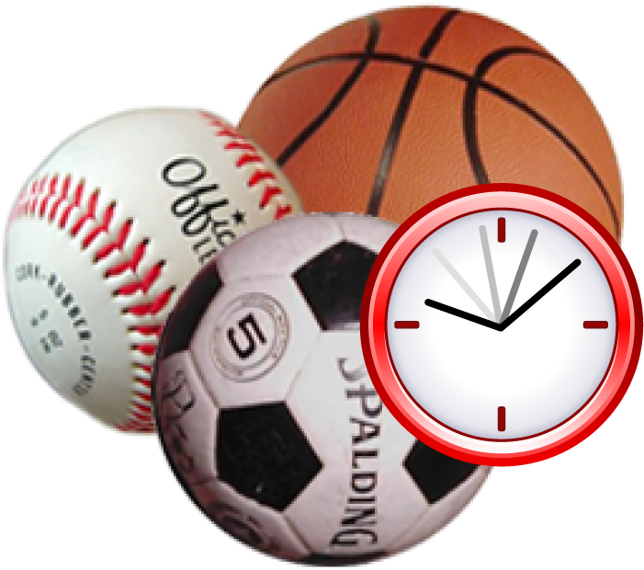

Upcoming Events

September 15
Recess Running Club begins and will be held every Tuesday/Thursday during recess times. (weather permitting)
Please contact Mrs. Smith if you would like to help with the club. dsmith@methacton.org
We really need more volunteers! Thank you!

Important Information
Sneakers in Physical Education class.
For students’ safety, proper footwear is needed in Physical Education classes. Sneakers should either lace or Velcro across the top of the foot for good ankle support.
Students who do not have proper footwear will have to sit out of class.
Crocs, sandals, slip-ons and flip flops are not to be worn in Physical Education class.

Arrowhead Elementary School
232 Level Rd. Collegeville, Pa. 19426
W: http://www.methacton.org/Domain/469
T: 610-489-5000 ext 44214
Dear Reader,
Welcome to our first installment of the Elementary Health and Physical Education Newsletter. In this newsletter, you will find what is going on in Health and Physical Education classes and other information related to health and wellness.
Sincerely,
Mrs. Smith and Mrs. Seibert

Physical Education: Not the “Gym Class from the Past”
Too often, parent’s memories of “gym class” center on experiences of teachers rolling out a ball or forcing students to climb the ropes. As we begin the new school year, we wanted to start this inaugural newsletter with an overview of what physical education is like in the Methacton School District elementary schools.
Today’s physical education programs are exciting and inclusive. Our curriculum has a foundation in fitness and is student centered. All skills taught, manipulative, motor, gymnastics, rhythmic, striking and ball skills are all related to developing and maintaining individual physical fitness. As with all other levels, personal and social responsibility and safety are key components to our program.
“You’re not fully educated until you’re physically educated.”

Kindergarten, 1st and 2nd Grade curriculum
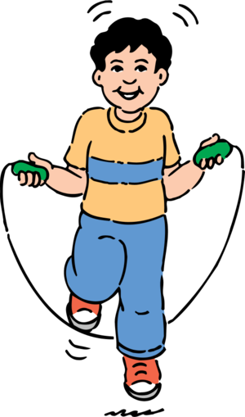
Our Goal
The goal of Physical Education is to develop “physically literate” individuals who have the knowledge, skills and confidence to enjoy a lifetime of healthful physical activity.
To pursue a lifetime of healthful physical activity, a Physically literate individual:
- Has learned the skills necessary to participate in a variety of physical activities
- Knows the implications of and the benefits from involvement in various types of physical activities
- Is physically fit.
- Values physical activity and its contributions to a healthful lifestyle.

Source: SHAPE America 2005

K- 2nd grades start the school year with Basic Movement Skills and Concepts Unit followed by Playground Games.
Skills and Concepts addressed:
- Locomotor movements- walk, jog, run, hop, gallop, skip, leap, slide, jump and crawl
- Non-locomotor skills-bend, stretch, twist, spinning, shake, sway, swing
- Combination movements
- Spatial awareness concepts- self-space, levels, pathways and directions

3rd and 4th Grade curriculum
Students in 3rd and 4th grade will start with our Playground Games unit followed by Football Lead-up Games.
Skills and Concepts addressed:
- Rules of Play
- Sportsmanship
- Resolving conflicts
- Safe practices

Volunteers needed for Recess Running Club
If you are interested in helping during one of the 2nd - 4th grade recess times on Tuesday or Thursday, please contact Mrs. Smith.

Meet the Physical Educators

Mrs. Smith
College: West Chester University/Gratz College
Hobbies/Interests: Running, yoga, yoga dance, organic gardening, hiking, biking, aromatherapy and family time

Mrs. Seibert
College: East Stroudsburg University
Arcadia University
Hobbies/Interests: Spending time with my family, travel, beach
Walking, spinning, gardening, running activities for disability camp

